ICT 211

DATABASE DESIGN

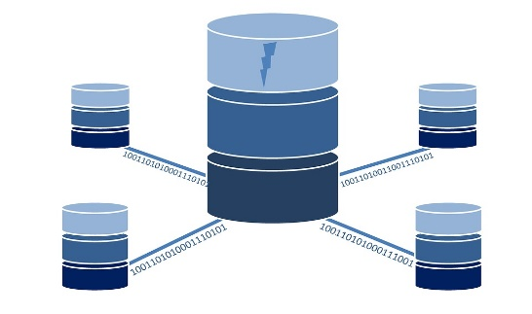++

Prepared by: PRADIP BHATTA

Submitted to

Words count: 1526

UNIVERSITY OF THE SUNSHINE COAST, QUEENSLAND, Australia.

Table of Contents

PART- A 3

ENTITY RELATIONSHIP DIAGRAM 3

RELATIONAL SCHEMA 4

Data dictionary 5

ASSUMPTIONS 5

PART- B 6

SQL 6

creating the statement of table: 6

Altering of the table 8

Trigger statement 9

Creating the function and calculation 9

Insert statement 10

Select statement 14

# PART- A

## ENTITY RELATIONSHIP DIAGRAM

Entity relationship diagram (ERD), is a structural diagram representation of entity, their relationship between each other in the data base. It consists of different symbol and connection and cardinality between the entities.

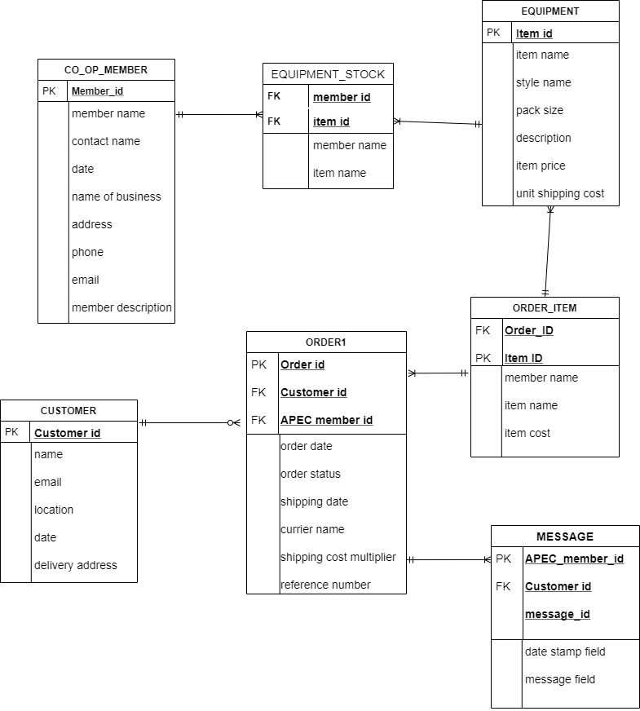

Figure 1: Entity Relationship Diagram in Crows Foot Notation

Emily Plunkett who loved to organise the wedding receives a lot of small / large catering service requests. She decided to work as a co-operator to provide advice and event organisation equipment. So, Emily went to Liam, a local web developer to create a website for The Australian Event Planning Co-operative. Liam created a web site for AEPC. The number of co-operative members increased, customers and supply organisation owners found data anomalies occurring and an increase in retrieval time for information. Furthermore, information about the order went missing and there were some difficulties in entering new information. Liam doesn't have a lot of experience about designing the database.  So, Emily and Liam came to me, to solve the problem. I suggest creating a Customer Relationship Management (CRM) type database that could be modified later. The core database entities are co-op, customers, equipment item and orders of equipment.

## RELATIONAL SCHEMA

Relation schema is the database tool which represent the collection of data and helps in analysing the data. I have created the relation table and it shows the relation of all data from the row. The data from the row helps to find how the data is organized.

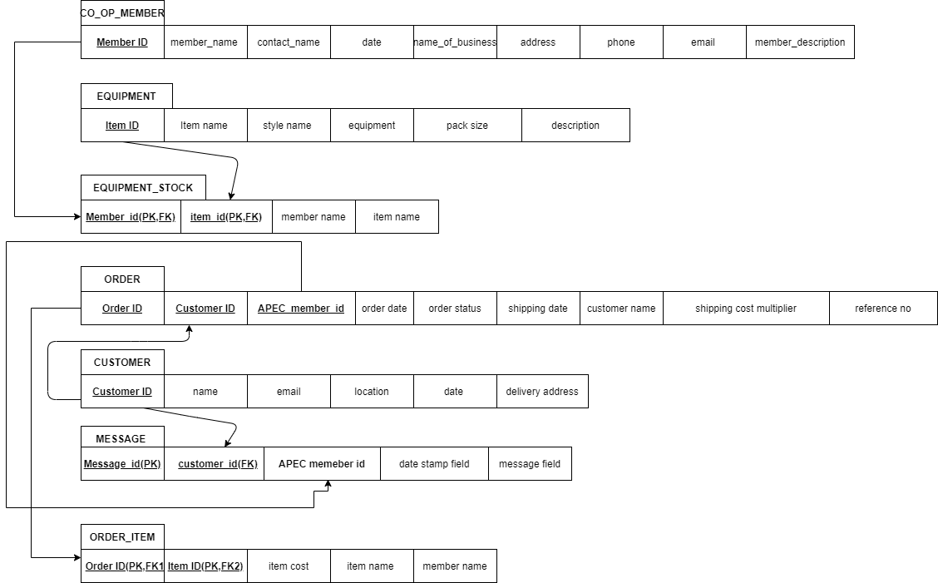

# Data dictionary

Data dictionary in the database is the meta data that provides data information, data elements, meaning and type of data. Each attribute is defined from the table. The Data dictionary elements are:

1. Attribute name: in database, each table is assigned with unique attribute name representing the table. for example; customer_id, customer_ name.
2. VARCHAR data type: varchar data type is the variable length data type model in data base. I have assigned varchar (255), it means defined length is 255.
3. Not null data type: Not null data type can’t be left blank. IT must be assigned with some values. If no values are insert in the field; it will execute an error.
4. Integer data type: It represent the data type of mathematical range. Integer data type cannot be negative.
5. Date data type: This data type stores the data in integer format in mm/dd/yyy.

## ASSUMPTIONS

* Each type of equipment’s may be stocked by many co-op members and each co-op members will stock many different types of equipment. So, I have assigned another table equipment_stock to resolve the relationship.
* The price of each item of equipment and the pack sizes are standard across the co-operative.
* The customers may order items from any AEPC members. Each order must include one or more order items.
* Estimation of the total cost including shipping cost is stored in the database.
* Message is sent to the customer when the order is placed using APEC member id.
* All the data are not given, so I have assumed some of the values for customer_id, APEC member_id.

# PART- B

## SQL

## creating the statement of table:

Statement of table in data base include all the data of the system. CREATE TABLE statement helps to create the new table in the system and store the data.

1. Create table coopmember(

MemberID int(11) PRIMARY KEY NOT NULL,

Member_name varchar(255) NOT NULL,

Contact_name varchar(255) NOT NULL,

Date date,

Name_of_business varchar(255) NOT NULL,

Address varchar(255) NOT NULL,

Phone int(11) NOT NULL,

Email varchar(255) NOT NULL,

Member_description varchar(255) NOT NULL

);

2. Create table customer(

Customer_id int(11) PRIMARY KEY NOT NULL,

Name varchar(50) NOT NULL,

Email varchar(50) NOT NULL,

Location varchar(50) NOT NULL,

Date datetime,

Delivery varchar(255) NOT NULL

);

3. Create table equipment(

item_id int(11) PRIMARY KEY NOT NULL,

item_name varchar(50) NOT NULL,

style_name varchar(50) NOT NULL,

description varchar(250) NOT NULL,

item_price int(11) NOT NULL

unit_shipping_cost int(11)

);

4. Create table equipment_stock(

Member_id int(11) PRIMARY KEY NOT NULL,

Item_id int(11) NOT NULL,

Member_name varchar(250) NOT NULL,

Item_name varchar(250) NOT NULL

);

5. create table message(

APEC_message_id int(11) PRIMARY KEY NOT NULL,

Customer_id int(11) NOT NULL,

Message_id varchar(255) NOT NULL,

Date_stamp_field date,

Message_field varchar(255) NOT NULL

);

6. Create table order1(

order_id int(11) PRIMARY KEY NOT NULL,

APEC_member_id int(11) NOT NULL,

Order_date date NOT NULL,

Order_status varchar(255) NOT NULL,

Shipping_date date NOT NULL,

Currier_name varchar(255) NOT NULL,

Shipping_cost_multiplier varchar(255) NOT NULL,

Reference_number varchar(255) NOT NULL,

Customer_id int(11) NOT NULL,

Customer_name varchar(255) NOT NULL,

Account_number int(11) NOT NULL,

Item_name varchar(255) NOT NULL,

Quantity int(11) NOT NULL,

Price decimal(10,4) NOT NULL,

Shipping_cost int(11) NOT NULL

);

7. Create table order_item(

Item_id int(11) PRIMARY KEY NOT NULL,

Order_id int(11) NOT NULL,

Member_name varchar(255) NOT NULL,

Item_name varchar(255) NOT NULL,

Item_cost varchar(255) NOT NULL

);

## Altering of the table

ALTER TABLE statement helps to add, drop, update, delete column in the table.

Alter table equipment_stock  
ADD FOREIGN KEY (item_id) REFERENCES equipment(item_id);

Alter table message  
ADD FOREIGN KEY (customer_id) REFERENCES customer(customer_id);

Alter table order1  
ADD FOREIGN KEY (customer_id) REFERENCES customer(customer_id);

Alter table order_item  
ADD FOREIGN KEY (order_id) REFERENCES order1(order_id);

## Trigger statement

It is a separate procedure function in the data base which automatically run in the system when certain even occurs.

DELIMITER //

create trigger insert_massage

after insert on order1

For Each Row

Begin

insert into messsage

set message_field= "customer order is placed";

END//

DELIMITER ;

## Creating the function and calculation

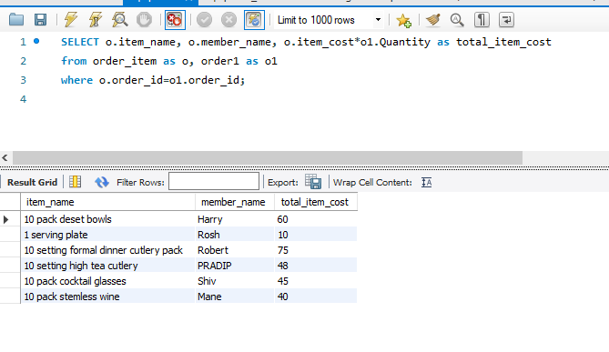

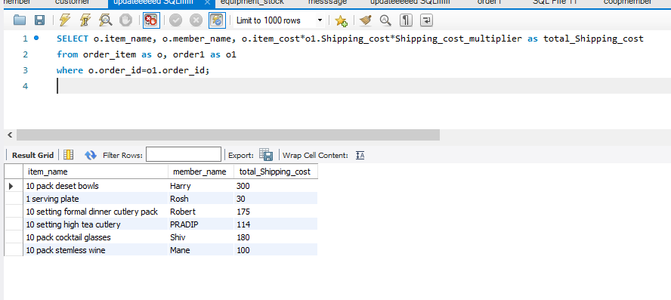

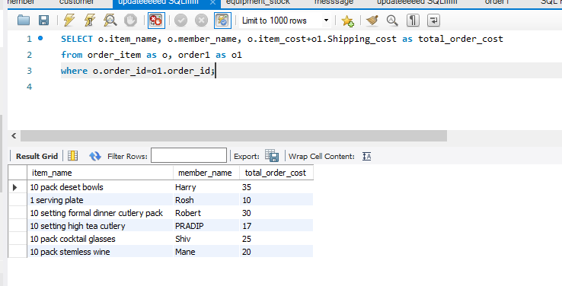

Figure 2: Creating the function and calculation

## Insert statement

Insert into statement is the most important statement in the data base. It is used to add data in the row.

syntax

insert into customer(customer_id, name, email, location, date, delivery)

values('1001', 'Harry', 'Harry@gmail.com', 'SYD NSW', '2020-01-01','SYD NSW');

insert into customer(customer_id, name, email, location, date, delivery)

values('1002', 'Rosh', 'Rosh@gmail.com', 'SYD NSW', '2020-02-02','VIC');

insert into customer(customer_id, name, email, location, date, delivery)

values('1003', 'Robert', 'Robert@gmail.com', 'QLD', '2020-03-03','NT');

insert into customer(customer_id, name, email, location, date, delivery)

values('1004', 'PRADIP', 'Pradip@gmail.com', 'QLD', '2020-04-04','vic');

insert into customer(customer_id, name, email, location, date, delivery)

values('1005', 'Shiv', 'Shiv@gmail.com', 'VIC', '2020-05-05','SA');

insert into customer(customer_id, name, email, location, date, delivery)

values('1006', 'Mane', 'Mane@gmail.com', 'TAS', '2020-06-06','TAS');

INSERT INTO equipment_stock(member_id, item_id, member_name, item_name)

values('1', '10', 'Julian Boucher', '10 pack deset bowls');

INSERT INTO equipment_stock(member_id, item_id, member_name, item_name)

values('2', '11', 'Anthony Singh', '1 serving plate');

INSERT INTO equipment_stock(member_id, item_id, member_name, item_name)

values('3', '12', 'Terri romano', '10 setting formal dinner cutlery pack');

INSERT INTO equipment_stock(member_id, item_id, member_name, item_name)

values('4', '13, 'George grant', ' 10 setting high tea cutlery');

INSERT INTO equipment_stock(member_id, item_id, member_name, item_name)

values('5', '14', 'Alison Cooper', '10 pack cocktail glasses');

INSERT INTO equipment_stock(member_id, item_id, member_name, item_name)

values('6', '15', 'Bethany Major', '10 pack stemless wine');

insert into order1(order_id, APEC_member_id, order_date, order_status, shipping_date, currier_name, shipping_cost_multiplier, refrence_number, customer_id, customer_name, account_number, item_name, quantity, price)

values('2001', '3001', '2020-03-03', 'order received', '2020-03-04', 'ebay', '1','11111', '1001','Harry', '111312', '10 pack deset bowls','3', 20);

insert into order1(order_id, APEC_member_id, Order_date, Order_status, Shipping_date, Currier_name, Shipping_cost_multiplier, Reference_number, customer_id, Customer_name, Account_number, Item_name, Quantity, Price, Shipping_cost)

values('2002', '3002', '2020-02-05', 'order received', '2020-02-06', 'Amozon', '1.2','11112', '1002','Rosh', '111313', '1 serving plate','2', 5, 5);

insert into order1(order_id, APEC_member_id, Order_date, Order_status, Shipping_date, Currier_name, Shipping_cost_multiplier, Reference_number, customer_id, Customer_name, Account_number, Item_name, Quantity, Price, Shipping_cost)

values('2003', '3003', '2020-03-05', 'order processing', '2020-03-08', 'wish', '1.4','11113', '1003','Robert', '111314', '10 setting formal dinner cutlery pack','3', 25, 5);

insert into order1(order_id, APEC_member_id, Order_date, Order_status, Shipping_date, Currier_name, Shipping_cost_multiplier, Reference_number, customer_id, Customer_name, Account_number, Item_name, Quantity, Price, Shipping_cost)

values('2004', '3004', '2020-04-05', 'order delivered', '2020-04-08', 'DHL', '1.9','11119', '1004','PRADIP', '111317', '10 setting high tea cutlery','4', 12, 5);

insert into order1(order_id, APEC_member_id, Order_date, Order_status, Shipping_date, Currier_name, Shipping_cost_multiplier, Reference_number, customer_id, Customer_name, Account_number, Item_name, Quantity, Price, Shipping_cost)

values('2005', '3005', '2020-06-05', 'on th way', '2020-04-08', 'ebay', '1.2','111122', '1005','Shiv', '111327', '10 pack cocktail glasses','3', 15, 10);

insert into order1(order_id, APEC_member_id, Order_date, Order_status, Shipping_date, Currier_name, Shipping_cost_multiplier, Reference_number, customer_id, Customer_name, Account_number, Item_name, Quantity, Price, Shipping_cost)

values('2006', '3006', '2020-05-09', 'Delivered', '2020-05-09', 'DHL', '1','1111778', '1006','Mane', '111341', '10 pack stemless wine','4', 10, 10);

insert into messsage(Customer_id, message_id, date_stamp_field, message_field, APEC_member_id)

values('1001', '11aa', '2020-01-05', 'order received', '3001');

insert into messsage(Customer_id, message_id, date_stamp_field, message_field, APEC_member_id)

values('1002', '11bb', '2020-02-05', 'order received', '3002');

insert into messsage(Customer_id, message_id, date_stamp_field, message_field, APEC_member_id)

values('1003', '11cc', '2020-03-05', 'order processing', '3003');

insert into messsage(Customer_id, message_id, date_stamp_field, message_field, APEC_member_id)

values('1004', '11dd', '2020-03-07', ' order delivered', '3004');

insert into messsage(Customer_id, message_id, date_stamp_field, message_field, APEC_member_id)

values('1005', '11ee', '2020-04-07', 'on the way', '3005');

insert into messsage(Customer_id, message_id, date_stamp_field, message_field, APEC_member_id)

values('1006', '11ff', '2020-05-08', 'Delivered', '3006');

####

insert into order_item(item_id, order_id, member_name, item_name, item_cost)

values('6001', '2001', 'Harry', '10 pack deset bowls', 20);

insert into order_item(item_id, order_id, member_name, item_name, item_cost)

values('6002', '2002', 'Rosh', '1 serving plate', 5);

insert into order_item(item_id, order_id, member_name, item_name, item_cost)

values('6003', '2003', 'Robert', '10 setting formal dinner cutlery pack', 25);

insert into order_item(item_id, order_id, member_name, item_name, item_cost)

values('6004', '2004', 'PRADIP', '10 setting high tea cutlery', 12);

insert into order_item(item_id, order_id, member_name, item_name, item_cost)

values('6005', '2005', 'Shiv', '10 pack cocktail glasses', 15);

insert into order_item(item_id, order_id, member_name, item_name, item_cost)

values('6006', '2006', 'Mane', '10 pack stemless wine', 10);

## Select statement

Select statement in the data base is used to view the information of the data.

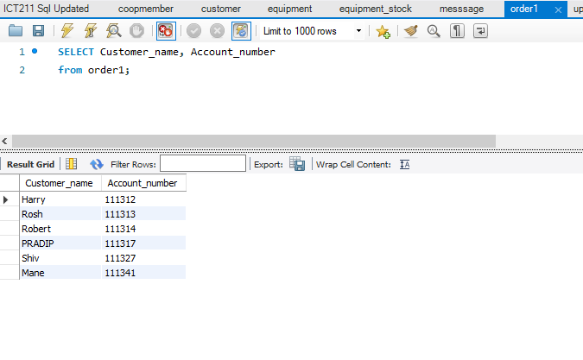

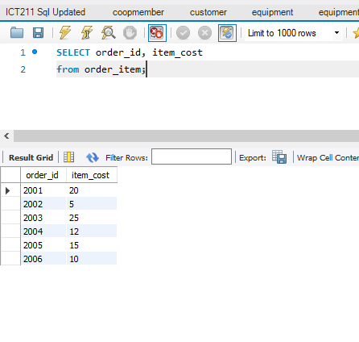

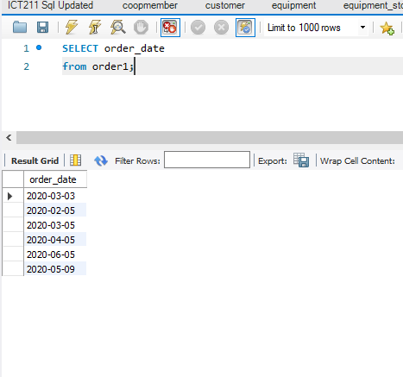

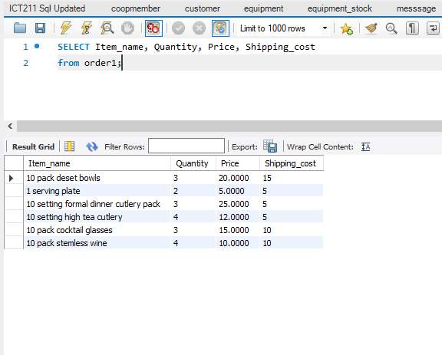

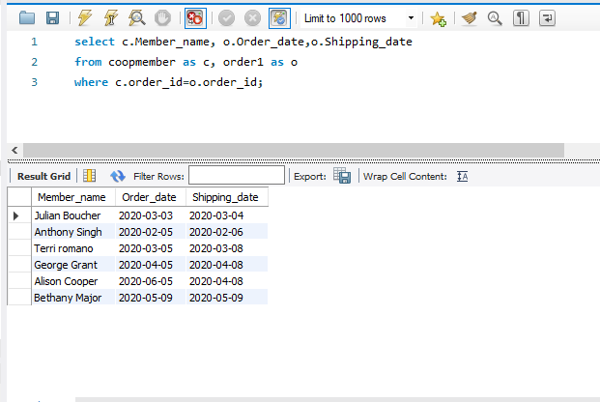

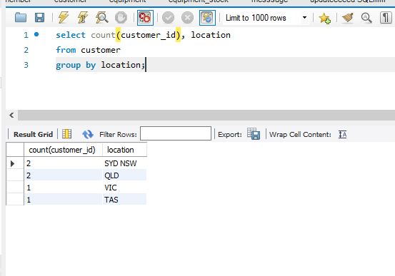

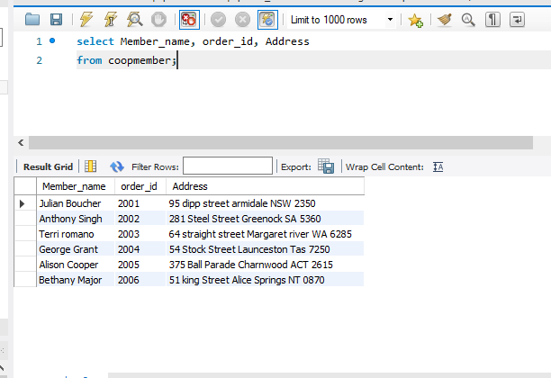

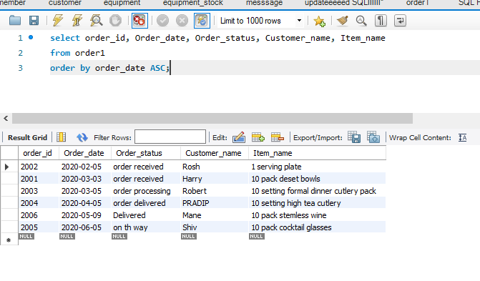

Figure 3: Select

Thank you!